|  |  |  |  |  |  |  |  |  |  |  |  |  |  |  |  |  |  |  |  |  |
| --- | --- | --- | --- | --- | --- | --- | --- | --- | --- | --- | --- | --- | --- | --- | --- | --- | --- | --- | --- | --- |
| |  |  |  |  | | --- | --- | --- | --- | | Sweet Potato | Red Onion | Honey | Toasted Sesame Oil | | Olive Oil | Salt | Brown Rice | Avocado | | Pepper | Chicken Breasts | Baby Spinach | Cilantro | | Garlic Powder | Ground Ginger | Garlic | Peanut Butter | | Lime | Low-Sodium Soy Sauce | Toasted Sesame Seeds |  |  Ingredients Without Measurements |

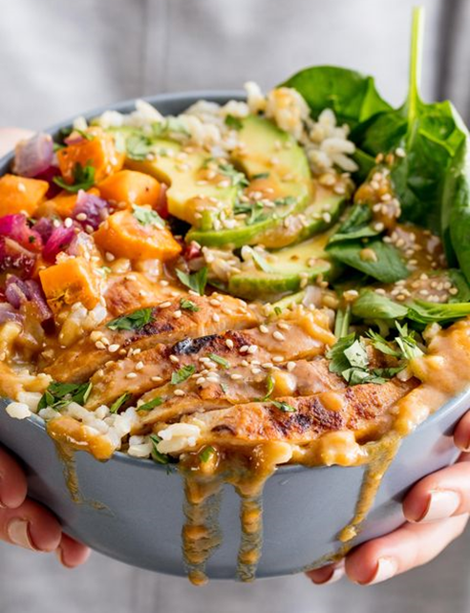Buddha Bowl

|  |
| --- |
| Ingredients With Measurements  * 1 large sweet potato, peeled and cut into ½ -inch cubes * 1 large red onion, diced * 3 tablespoon extra-virgin olive oil, divided * Kosher salt * Freshly ground black pepper * 1 lb. boneless, skinless chicken breasts * ½ teaspoon garlic powder * ½ teaspoon ground ginger * 1 small clove garlic, minced * 2 tablespoons creamy peanut butter * ¼ cup Juice of 1 lime * 1 tablespoon low-sodium soy sauce * 1 tablespoon honey * 1 tablespoon toasted sesame oil * 4 cup cooked brown rice * 1 avocado, thinly sliced * 2 cup baby spinach * 1 tablespoon Freshly chopped cilantro, for garnish * 1 teaspoon Toasted sesame seeds |

|  |
| --- |
| Recipe Preheat oven to 425°. On a large baking sheet, toss sweet potatoes and onion with 1 tablespoon of oil and season with salt and pepper. Bake until tender, 20 to 25 minutes.  Meanwhile, in a large skillet over medium- high heat, heat 1 tablespoon of oil. Season chicken with garlic powder, ginger, salt, and pepper. Cook until golden and no longer pink, 8 minutes per side. Let rest 10 minutes, then slice.  In a small bowl, whisk together garlic, peanut butter, lime juice, soy sauce, and honey. Whisk in sesame oil and remaining 1 tablespoon olive oil until smooth.  Divide rice among four bowls and top each with sweet potato mixture, chicken, avocado, and baby spinach. Sprinkle with cilantro and sesame seeds and drizzle with dressing before serving. |